RLC Series Circuit
When a pure resistance of R ohms, a pure inductance of L Henry and a pure capacitance of C farads are connected together in series combination with each other then RLC Series Circuit is formed. As all the three elements are connected in series so, the current flowing through each element of the circuit will be the same as the total current I flowing in the circuit.

The RLC Circuit is shown below:
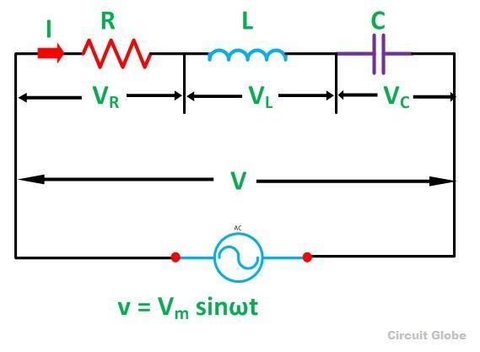

In the RLC Series circuit
X_{L} = 2πfL and X_{C} = 1/2πfC
When the AC voltage is applied through the RLC Series circuit the resulting current I flows through the circuit, and thus the voltage across each element will be:
- V_{R} = IR that is the voltage across the resistance R and is in phase with the current I.
- V_{L} = IX_{L} that is the voltage across the inductance L and it leads the current I by an angle of 90 degrees.
- V_{C} = IX_{C} that is the voltage across capacitor C and it lags the current I by an angle of 90 degrees.

Phasor Diagram of RLC Series Circuit
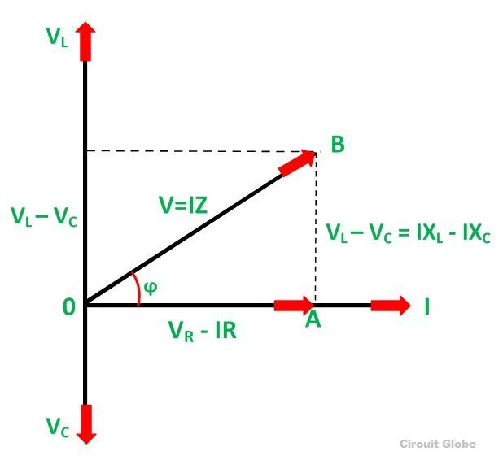
The phasor diagram of the RLC series circuit when the circuit is acting as an inductive circuit that means (V_{L}>V_{C}) is shown below and if (V_{L}< V_{C}) the circuit will behave as a capacitive circuit.

Steps to draw the Phasor Diagram of the RLC Series Circuit
- Take current I as the reference as shown in the figure above
- The voltage across the inductor L that is V_{L} is drawn leads the current I by a 90-degree angle.
- The voltage across the capacitor c that is V_{c} is drawn lagging the current I by a 90-degree angle because in capacitive load the current leads the voltage by an angle of 90 degrees.
- The two vector V_{L} and V_{C} are opposite to each other.
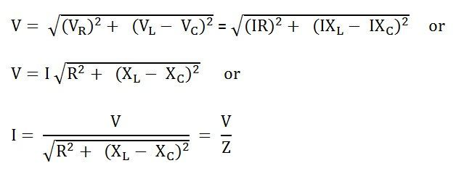Where,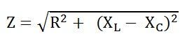It is the total opposition offered to the flow of current by an RLC Circuit and is known as Impedance of the circuit.
Phase Angle
From the phasor diagram, the value of phase angle will be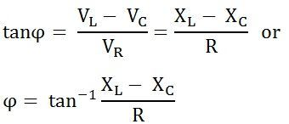
The three cases of RLC Series Circuit
- When X_{L} > X_{C}, the phase angle ϕ is positive. The circuit behaves as RL series circuit in which the current lags behind the applied voltage and the power factor is lagging.
- When X_{L} < X_{C}, the phase angle ϕ is negative, and the circuit acts as a series RC circuit in which the current leads the voltage by 90 degrees.
- When X_{L} = X_{C}, the phase angle ϕ is zero, as a result, the circuit behaves like a purely resistive circuit. In this type of circuit, the current and voltage are in phase with each other. The value of the power factor is unity.

Impedance Triangle of RLC Series Circuit
When the quantities of the phasor diagram are divided by the common factor I then the right angle triangle is obtained known as impedance triangle. The impedance triangle of the RL series circuit, when (X_{L} > X_{C}) is shown below:
If the inductive reactance is greater than the capacitive reactance than the circuit reactance is inductive giving a lagging phase angle.
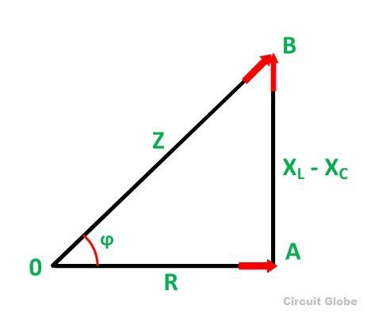

Impedance triangle is shown below when the circuit acts as an RC series circuit (X_{L}< X_{C})
Impedance triangle is shown below when the circuit acts as an RC series circuit (X_{L}< X_{C})
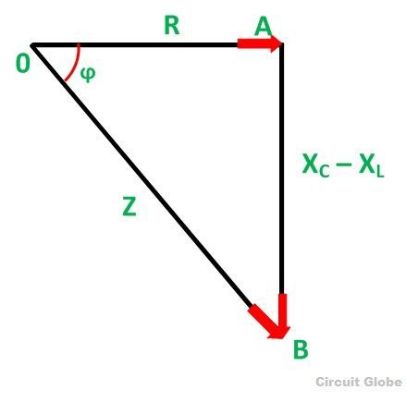When the capacitive reactance is greater than the inductive reactance the overall circuit reactance acts as capacitive and the phase angle will be leading.

Applications of RLC Series Circuit
The following are the application of the RLC circuit:
- It acts as a variable tuned circuit
- It acts as a low pass, high pass, bandpass, bandstop filters depending upon the type of frequency.
- The circuit also works as an oscillator
- Voltage multiplier and pulse discharge circuit

Series Resonance
In the RLC series circuit, when the circuit current is in phase with the applied voltage, the circuit is said to be in Series Resonance. The resonance condition arises in the series RLC circuit when the inductive reactance is equal to the capacitive reactance.
X_{L} = X_{C} or (X_{L} – X_{C} = 0)
A series resonant circuit has the capability to draw heavy current and power from the mains; it is also called acceptor circuit. The series resonance RLC circuit is shown in the figure below:
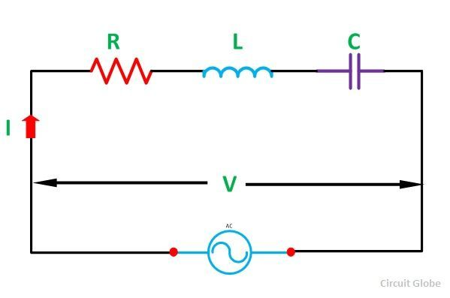At the resonance : X_{L} – X_{C} = 0 or X_{L} = X_{C}
The Impedance will be:
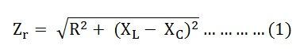Where Zr is the resonance impedance of the circuit.
Putting the value of X_{L} – X_{C} = 0 in equation (1) we will get:
Zr = R
Current I = V/ Z_{r} = V/R
Since at resonance the opposition to the flow of current is only resistance (R) of the circuit. At this condition, the circuit draws the maximum current.

Effects of Series Resonance
The following effects of the series resonance condition are given below:
- At resonance condition, X_{L} = X_{C} the impedance of the circuit is minimum and is reduced to the resistance of the circuit. i.e Z_{r} = R
- At the resonance condition, as the impedance of the circuit is minimum, the current in the circuit is maximum. i.e I_{r} = V/Z_{r} = V/R
- As the value of resonant current Ir is maximum hence, the power drawn by the circuit is also maximized. i.e P_{r} = I²R_{r}
- At the resonant condition, the current drawn by the circuit is very large or we can say that the maximum current is drawn. Therefore, the voltage drop across the inductance L i.e (V_{L} = IX_{L} = I x 2πfrL) and the capacitance C i.e (V_{C} = IX_{C} = I x I/2πf_{r}C) will also be very large.

Resonant Frequency
The resonant frequency condition arises in the series circuit when the inductive reactance is equal to the capacitive reactance. If the supply frequency is changed the value of X_{L} = 2πfL and X_{C} = 1/2πf_{C} is also changed.
When the frequency increases, the value of X_{L} increases, whereas the value of X_{C} decreases. Similarly, when the frequency decreases, the value of X_{L} decreases and the value of X_{C} increases.
Thus, to obtain the condition of series Resonance, the frequency is adjusted to f_{r}, point P as shown in the curve below. At point P when (X_{L} = X_{C}) the resonant frequency condition is obtained.

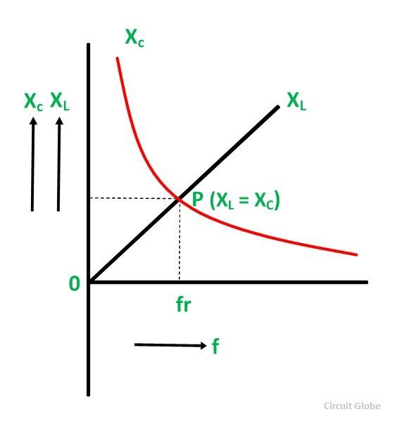
At series resonance, when X_{L} = X_{C}
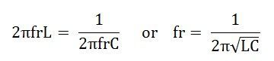
Where fr is the resonant frequency in hertz when inductance L is measured in Henry and capacitance C in Farads.

